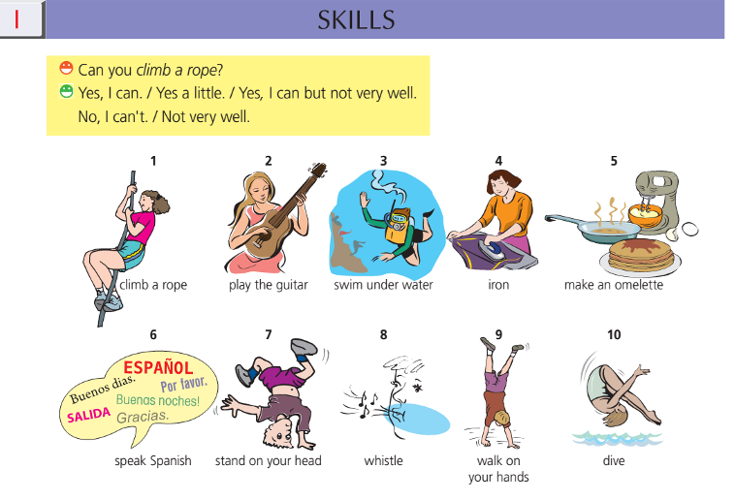
Pozdravljeni učenci.
Upam, da so za vami lepi prazniki.
V učbeniku na strani 110 imamo veliko besednih zvez ,s pomočjo katerih bomo tvorili vprašanja s CAN..?
1. Najprej napišite v zvezek datum in naslov učne ure- SKILLS: Can you climb a robe?
Izpišite besedne zveze:

climb a rope- plezati po vrvi
play the guitar- igrati kitaro
swim under water- plavati pod vodo
iron- likati
make an omellete- narediti omleto
speak Spanish- govoriti špansko
stand on your head- stati na glavi
whistle- žvižgati
walk on your hands- hoditi po rokah
dive- skočiti v vodo

2. Potem izberite 6 primerov in napišite kratke dialoge.
Primer:
Can you SWIM?
Yes, I can./ Yes a little./ Yes I can but not very well./ No, I can't. / Not very well( ne dobro)
Seveda sam izbereš ustrezen odgovor.
Te dialoge mi poslikajte in mi slikano pošljite na moj e mail naslov jasmina.repolusk@os-dobrna.si
do četrtka, 16. 4. 2020.
3. Tisti učenci, ki imate več časa in si to želite, pa rešite spodnjo bralno nalogo in pošljite rešitve, da jih popravim.

Preberi besedilo in na podlagi zapisanega KRATKO odgovori na vprašanja.
Glej primer 0, ki je že rešen. ___/6

GROWING UP ON THE WATER

Hi, my name is Lauren. I live in Ventura, California, which has perfect weather
and is right by the ocean. For almost 11 years, I have lived on a sailboat. There are a
variety of sailboats and motorboats in the dock that we live on. Inside the boat, there
is a bathroom, a bunk and two closets. Separated by a curtain, there is a nice sitting
area that can seat seven people and a table with a television in one corner. At the
back of the boat there is a stove, an oven and a sink so we can prepare meals there.
We have a refrigerator and a freezer also. There is a small bunk that my younger
sister sleeps in and a nicely sized bed beside it where my parents sleep.
The best thing about living on the boat is the underwater life. Almost every
morning we see crabs, lobsters and stingrays. The worst thing about living on the
boat is that it is so small.
My parents are English but they moved to the USA just before I was born. My
mother is a therapist and my father is a network technician. I go to Anacapa Middle
School and take Spanish, math, English, US history and science.
Summer holidays include going to San Francisco, Yosemite National Park,
Washington State, Monterey, and many more places. In my free time I watch
television. I like Hannah Montana and American Idol, but my favourite show is Planet
Earth, because the beauty they capture is spectacular. I love going on the computer
and e-mailing people and talking to them online. I do figure skating three times a
week and do arts and crafts. I like to play with my dog, Mae, for fun. She is 3 years
old and loves playing outside. She is just the right size to have her on the boat. I don't
see myself living on the boat in the future, but the memories that I have of the boat
will always be fond ones.

Primer:
0. What is Lauren's home? A sailboat.

1. Where is the kitchen area on Lauren's sailboat?
_________________________________________
2. Why does Lauren think that life on the boat is difficult? _______________________
3. Which foreign language does Lauren learn at school? ____________________________________________
4. What TV programme does Lauren like best?
_____________________________________________
5. Which sport does Lauren do?
_____________________________________________
6. How big is Lauren's pet?
______________________________________________

Želim vam uspešno delo!
Jasmina Gojčič

