PREVERJANJE, Progress check English 7. th Class TJA Name:______________________________
1. ___/10
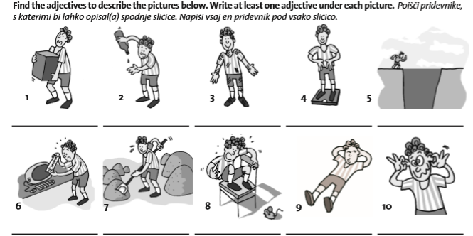
2. ____/7
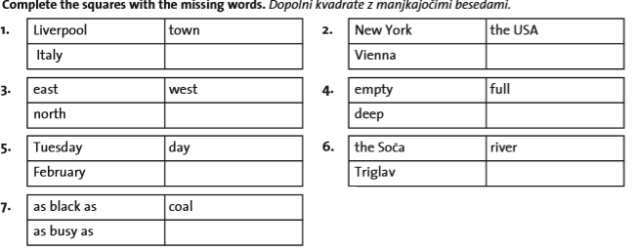
3. _____/16
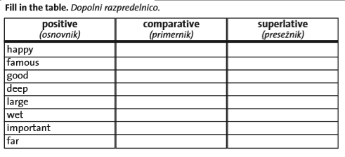

4. ____/5
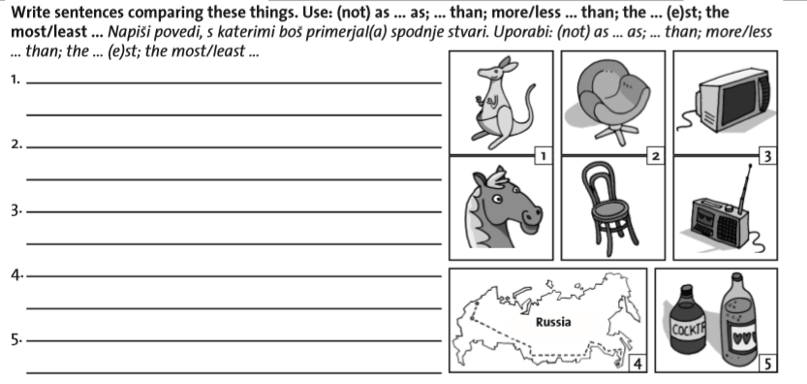

5. ____/7
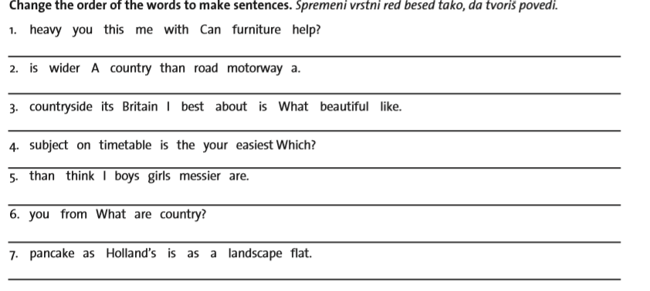

6. ____/7
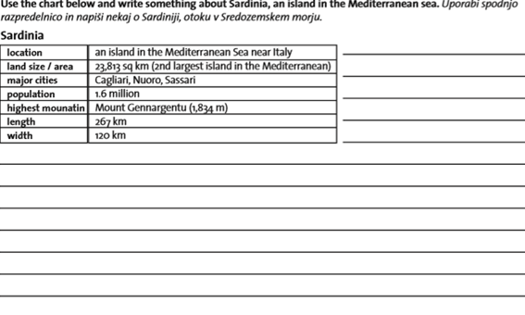
_____/52 points

wide-širok
width- širina
length- dolžina

